Computer Shop System

Version 1.0

Revision History

|  |  |  |  |
| --- | --- | --- | --- |
| **Date** | **Version** | **Description** | **Author** |
| 10/11/2019 | 1.0 | details | Pham Thi Hong Trang |
|  |  |  |  |
|  |  |  |  |
|  |  |  |  |

Table of Contents

1. Use-Case Name 3

1.1 Brief Description 3

2. Flow of Events 3

2.1 Basic Flow 3

2.2 Alternative Flows 3

2.2.1 < First Alternative Flow > 3

2.2.2 < Second Alternative Flow > 3

3. Special Requirements 3

3.1 < First Special Requirement > 3

4. Preconditions 3

4.1 < Precondition One > 3

5. Postconditions 3

5.1 < Postcondition One > 3

6. Extension Points 3

6.1 <Name of Extension Point> 3

# View Shopping Cart

## Brief Description

This use case defines how customer can see all computer which they added to shopping cart.

# Flow of Events

## Basic Flow

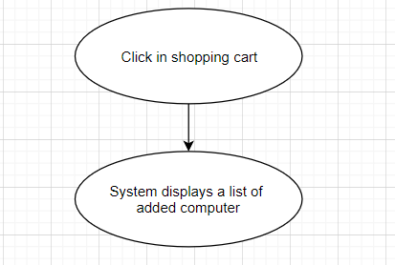

**Basic flow of viewing shopping cart**

# Special Requirements

No special requirements.

# Preconditions

No preconditions.

# Post conditions

No post conditions.

# Extension Points

No extension points.